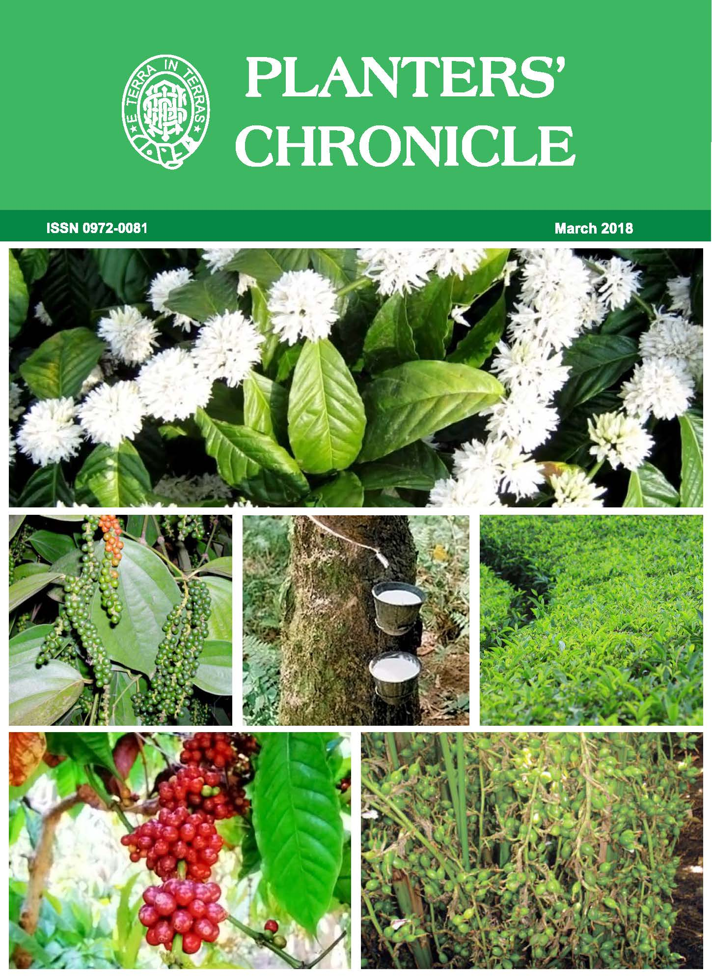

Planters’ Chronicle – March 2018- Vol.114 – No. 3

Main Topics

- Editorial – Labour Codes
- UPASI Representations
  - Labour Code on Wages Bill 2017
  - Labour Code on Industrial Relations Bill
  - Labour Code on Social Security 2018
- From the History: Old Wynaad – Excerpts of the Reminiscences of the Old Wynaad Planter - Continuation
- Glossary of some Terms used in Processing of Coffee in India (concluding part)

