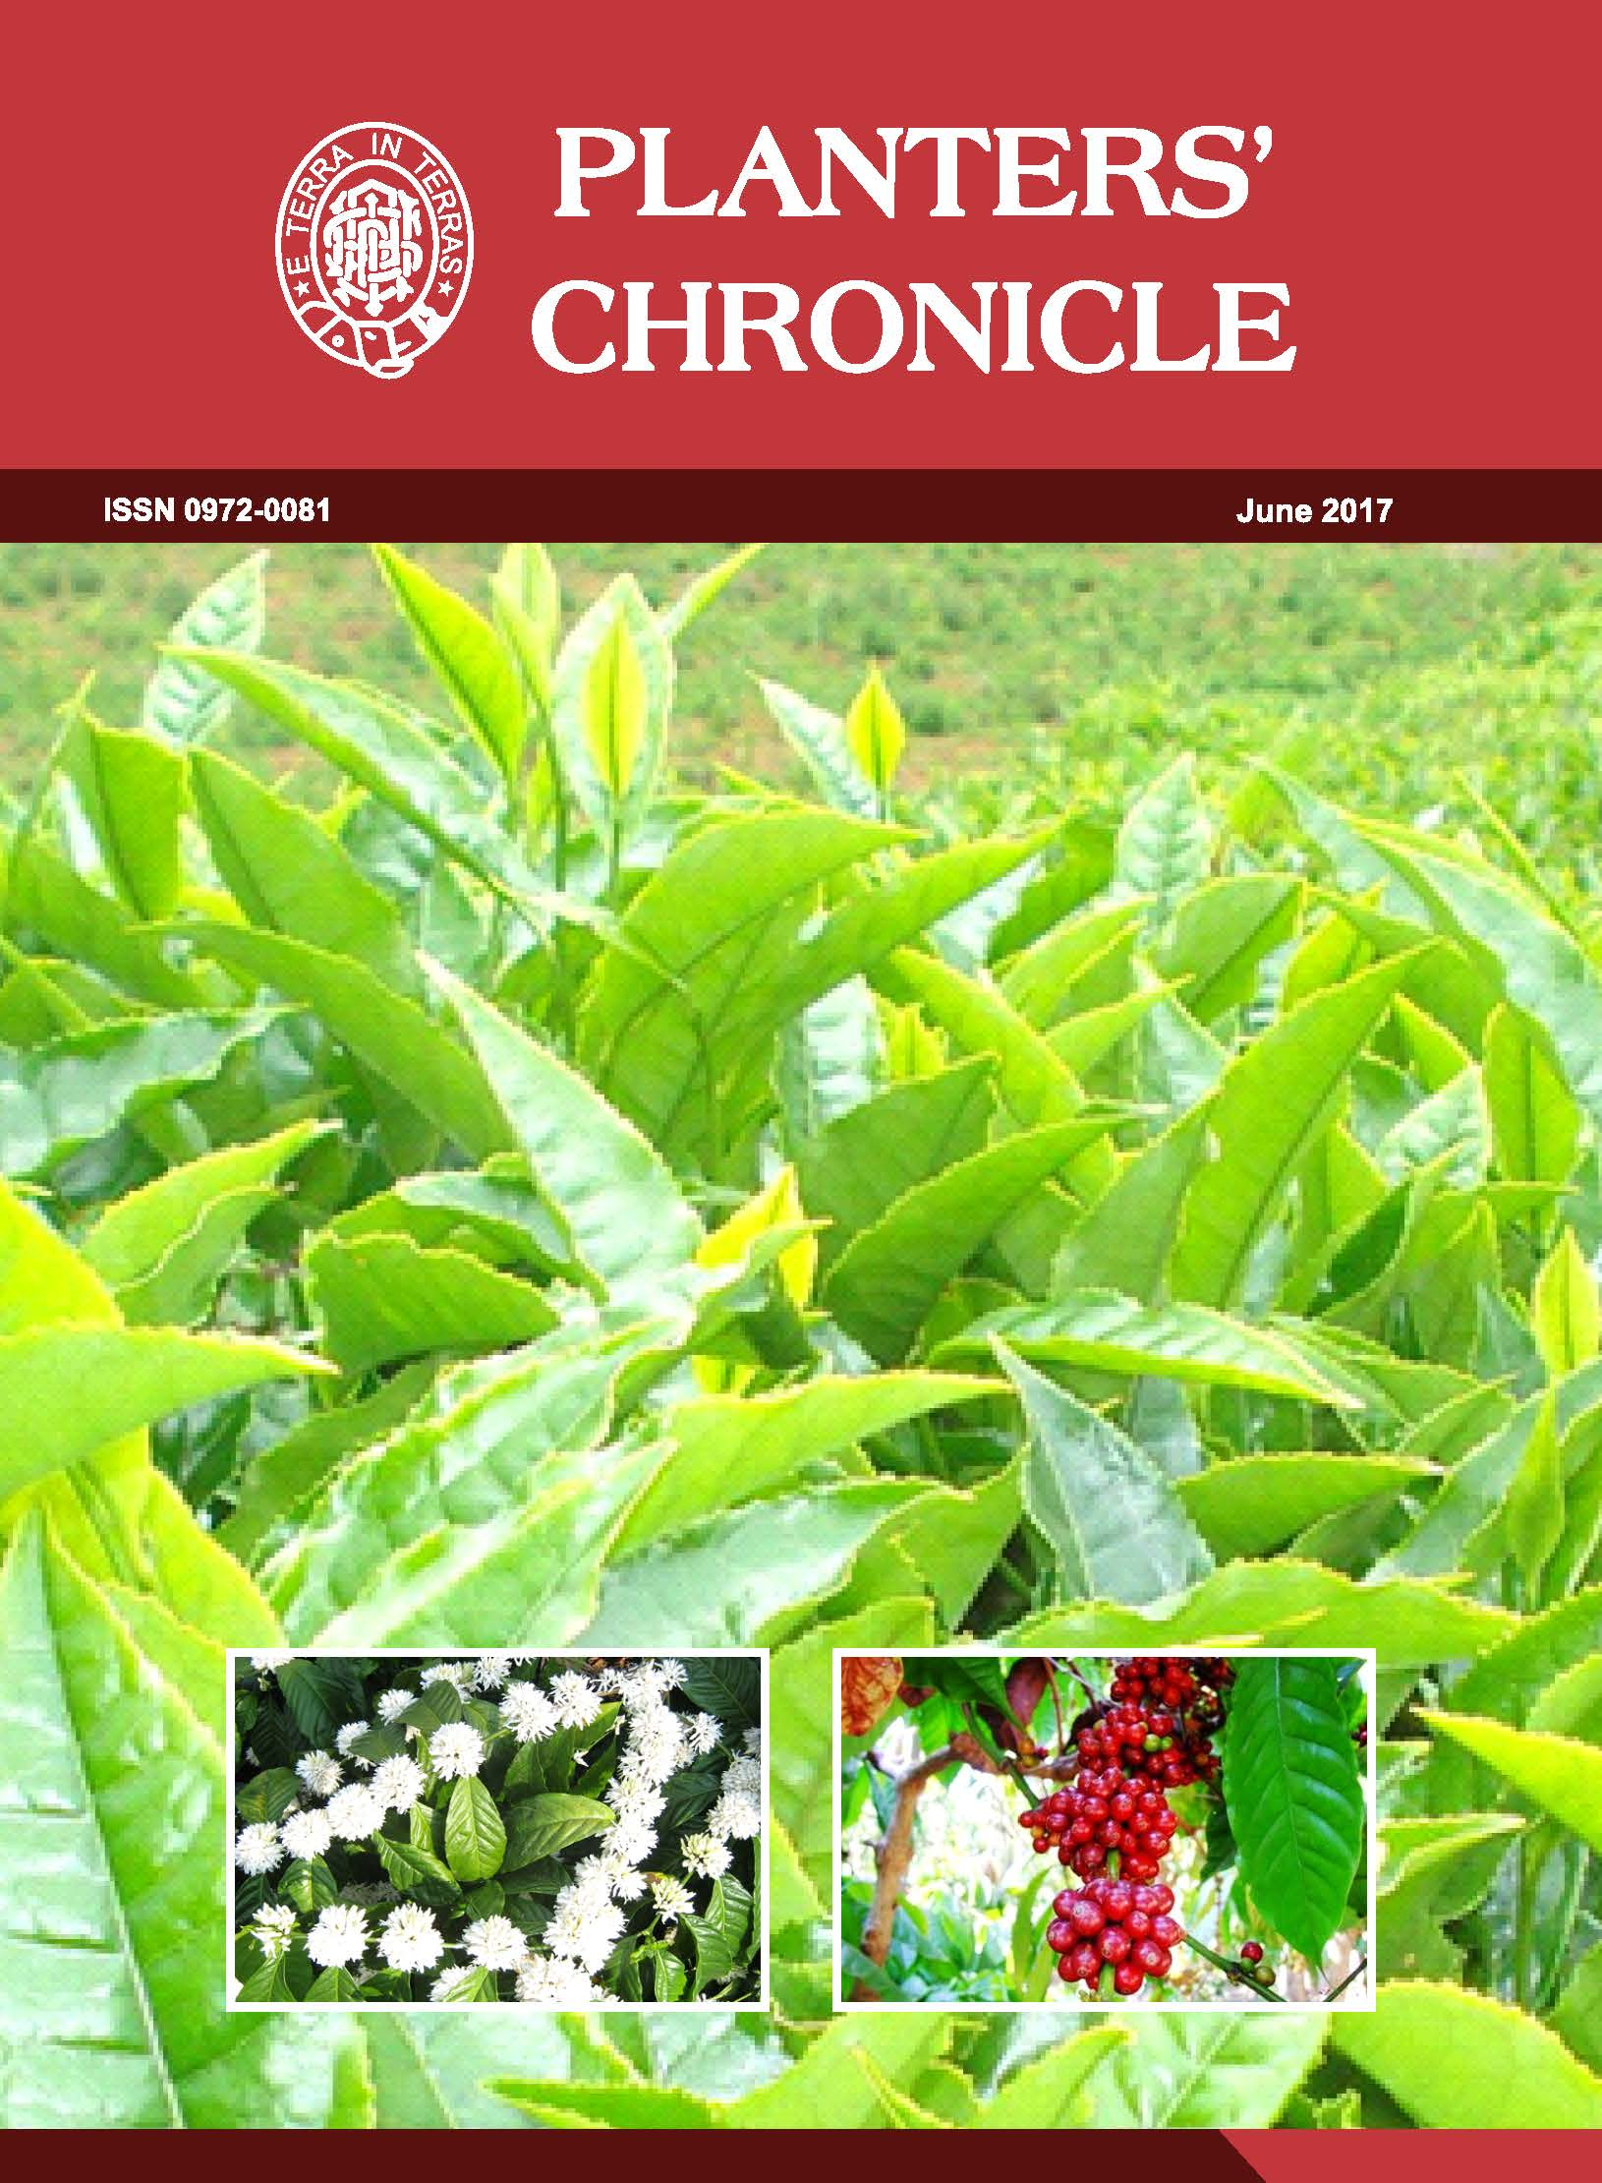

Planters’ Chronicle – June 2017- Vol.113 – No. 6

Main Topics

- Editorial –Goods and Service Tax (GST)

- Resurgence of Tea (In) Fusion for Health Benefits for Economy and Demand by Dr.T.C.Chaudhuri, Former Director (Research) and Hon Advisor, Tea Board of India; Secretary, National Tea Research Foundation

- Planters Contributions in Search of Superior Arabica Coffee Geneotypes for the Commercial Cultivation

- Advisory for Different Planting Districts in South India for the Month of July 2017

- Paths Less Trod in the Hills of South India by Mr.Ravi Mathews

- GST Concepts and Status

